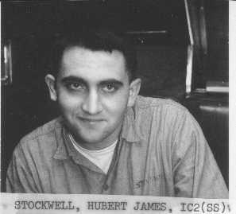

STOCKWELL, Hubert James, 70, St. Augustine, passed away peacefully on Dec. 23, 2016 at home surrounded by his family after battling a long illness. He was born in Spencer, West Virginia, son of the late Hubert F. and Hazel Stockwell. He served in the U.S. Navy, serving four years on submarines and then served four years as a reservist. He married in Louisville, Kentucky, and moved to Daytona Beach in 1979 and then to St. Augustine in 2000. He worked as an electrician and HVAC tech for the Volusia and St. Johns County school boards until his retirement. He was preceded in death by his wife of 42 years, Janice Stockwell, who died March 11, 2013. He was also preceded in death by two sisters, Rita Graycroft and Shirley Stockwell. He is survived by a son, William "Bill" Stockwell of St. Augustine; daughters, Ann Marie Oldenburg, and her husband, Rusty, of St. Augustine, and Katherine Stockwell of Daytona Beach; brother, John Stockwell, M.D.; and her precious grandchildren, Russell Jr., Cecilia, Katie, Joseph, Mattie, Gracie, and Fletcher. A memorial Mass will take place at 9 a.m. Monday at Corpus Christi Catholic Church. Interment will follow at San Lorenzo Cemetery. St. Johns Family Funeral Home is in charge of arrangements. Published in St. Augustine Record on Jan. 13, 2017

IC2(SS) 1967-1969

