Homeward Bound Submariners Now On Eternal Patrol
Brian Headden · November 17 at 1:57 PM ·

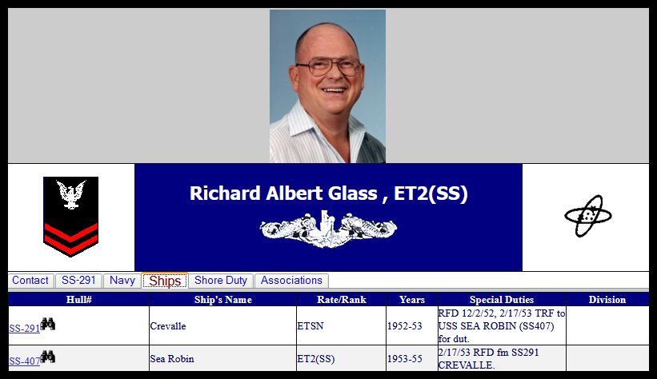

Eternal Patrol by USSVI
Favorites · November 17 at 1:54 PM ·
Korean War era Submarine Veteran, Richard (Dick) Albert Glass, 87, passed away on Thursday, November 11, 2021, in Farmington, NM.
Dick was born November 18, 1933, in Cleveland, OH, to Stanley Warren Glass and Lucille Mae Wells Glass.
Dick graduated from Schaaf High School in Parma, OH, in 1951. He married Dolores Irene Miller on July 4, 1952, in Cleveland.
He served in the Submarine Service of the U.S. Navy. He served aboard the USS Crevalle and USS Sea Robin, achieved the rank of Electronic Technician 3rd Class and was honorably discharged in 1954.
Dick and Dolores lived in New London, CT, Pittsburgh, PA, Palmdale, CA, and Cleveland before moving to Los Alamos, NM, in February, 1960. They also lived in Santa Fe, NM, while he worked for Los Alamos Scientific Laboratory until 1972. They moved to Farmington, and he worked for Arizona Public Service Co. until 1990.
Dick and Dolores were married 39 years before her death in August 1991.
He married Joyce Etheyl Dillard on October 14, 1995, in Farmington. They also lived in Aztec, NM.
He was a loving and caring husband and father, setting an example with a lifetime of hard work.
Dick was an avid model railroader, collecting model trains since boyhood. He was a member and officer of San Juan Valley Model Railroad Club. He designed and built model railroad layouts for several friends. He was among volunteers who helped rebuild washed out roadbed for Cumbres & Toltec Scenic Railroad. He enjoyed sailing, particularly on Vallecito Lake, CO. He was a square dance enthusiast. He and his wife, Dolores, enjoyed camping trips throughout New Mexico, Colorado and the Southwest, taking their family to numerous cultural and historic locations.
He was an avid reader and enjoyed reading his Bible and studying scripture with his wife, Joyce. He was a tenor in several church choirs, as well as playing in handbell choirs. He was a member of the First United Methodist Church in Farmington, where he met Joyce in the choir. Later he was a member of the Flora Vista Baptist Church.
Dick was preceded in death by his parents, his wife Dolores, his brother Warren Glass and his daughter Rebecca.
He is survived by his wife Joyce; sister Lorraine Slezak of Weirton, WV; sons Richard I. Glass and wife Norma of El Paso, TX, Dr. Robin I. Glass of Bloomfield, NM, Raymond L. Glass and wife Linda of Vallecito Lake (Bayfield, CO), and David W. Barnett of Rio Rancho, NM; and daughters Ramona L. Glass Richardson of Farmington, Kim M. Rowlands and husband Tim of Farmington, Adelia Z. Engram and husband Larry of Carlsbad, NM, and Renea Polo of Carlsbad. He is also survived by 19 grandchildren, 13 great-grandchildren and numerous nieces and nephews.

